**Assignment-19.1:**

*Convert Avro File to JSon type File using Hive.*

*Dataset Description: The data set consists of the following fields.*

*Athlete: This field consists of the athlete name*

*Age: This field consists of athlete ages*

*Country: This fields consists of the country names which participated in olympics*

*Year: This field consists of the year*

*Closing Date: This field consists of the closing date of ceremony*

*Sport: Consists of the sports name*

*Gold Medals: No of Gold medals*

*Silver Medals: No of Silver medals*

*Bronze Medals: No of Bronze medals*

*Total Medals: Consists of total no of medals*

*You can refer our below link Blog:*

[*https://acadgild.com/blog/avro-in-hive/*](https://acadgild.com/blog/avro-in-hive/)

* Avro data set is downloaded and displaced using cat command and screenshot was added below. 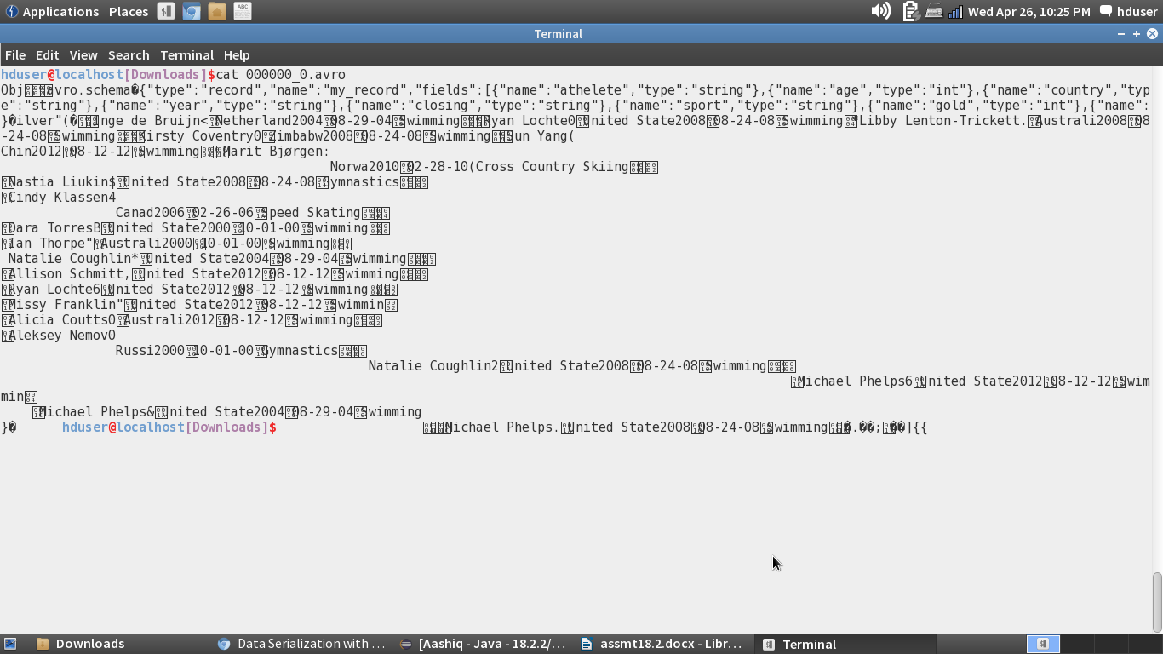
* avro-tools-1.7.5.jar is downloaded which helps to convert avro file format to JSon file format.

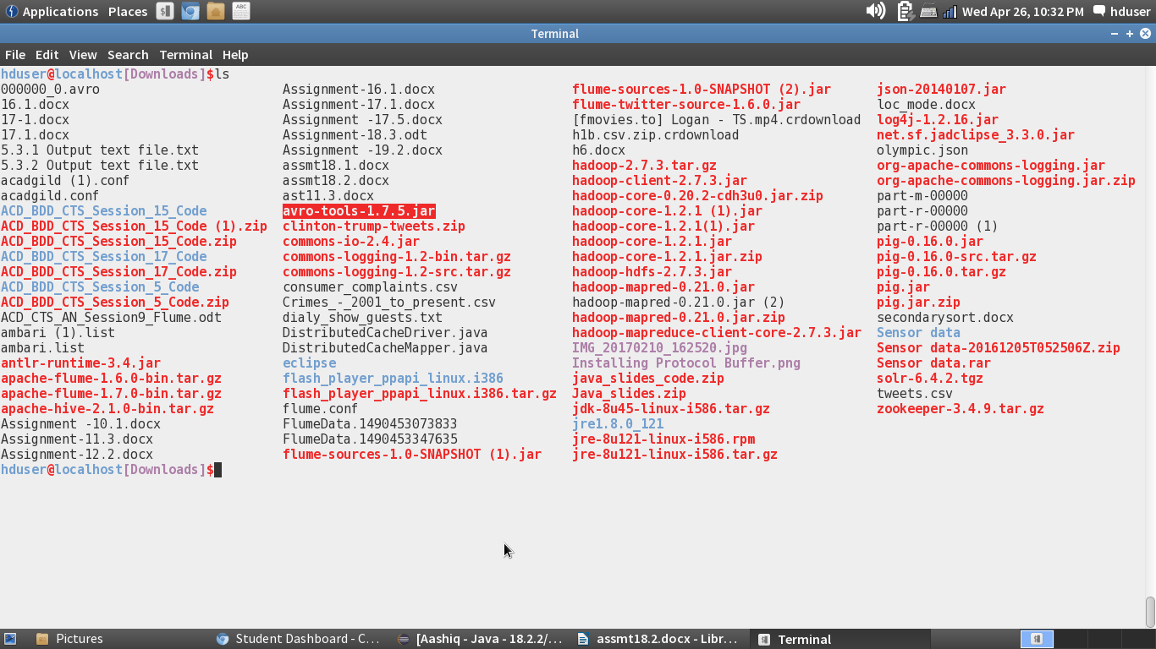

These commands were used to convert the avro File type to JSon File type

* + java -jar avro-tools-1.7.5.jar tojson 'avro file name' >olympic.json
  + Olympic.json file is displayed like this:

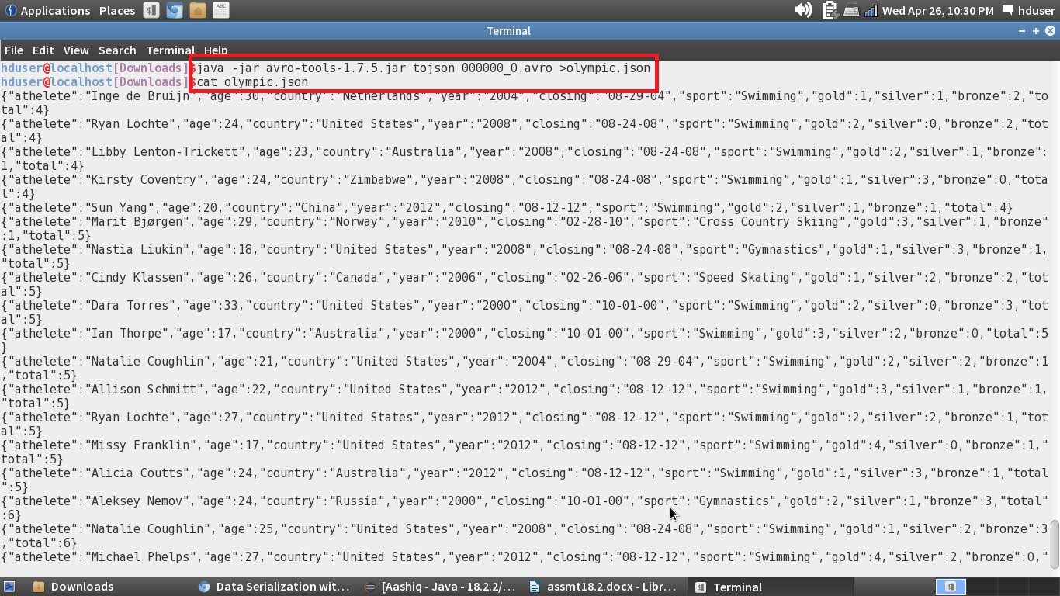

* A file called Olympic.json is created in the downloads folder and the file called json file will be in the github.

